1 Load Volume Data
Below is the normalized image to [0,1] interval:
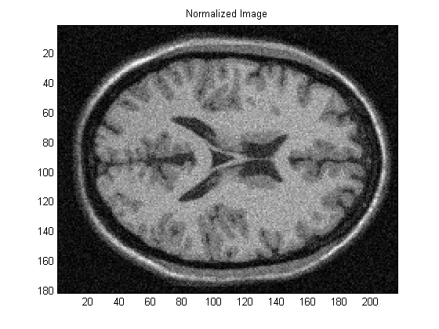

2 Perona Malik Diffusion Process (Explicit Form)
Below are the results of Perona-Malik diffusion process results for iterations of 10. The parameters associated with each image is given as the title of the image.

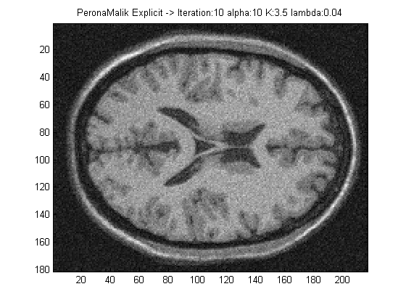 | 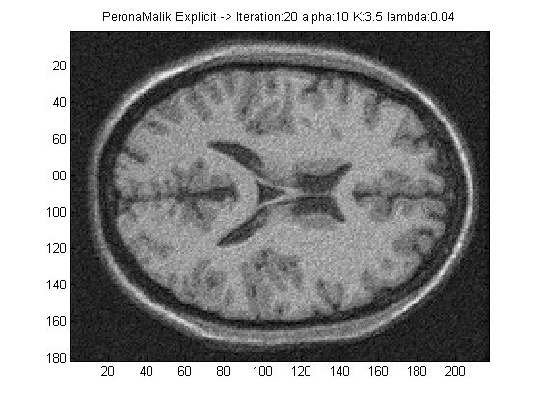
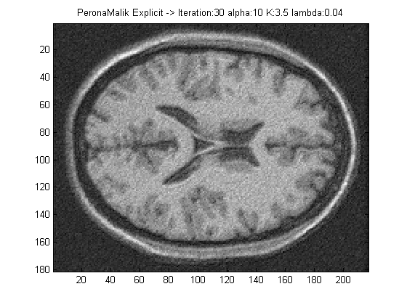 | 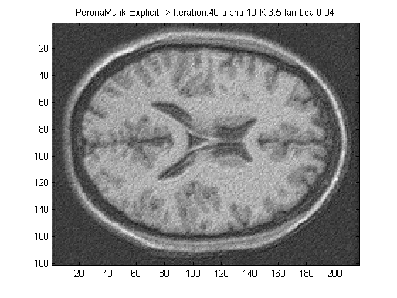
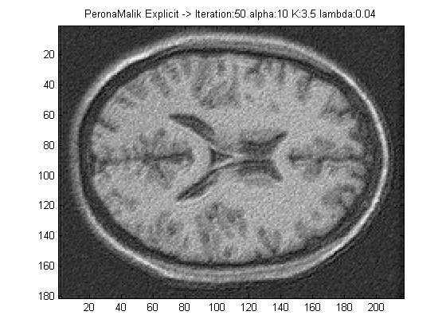 | 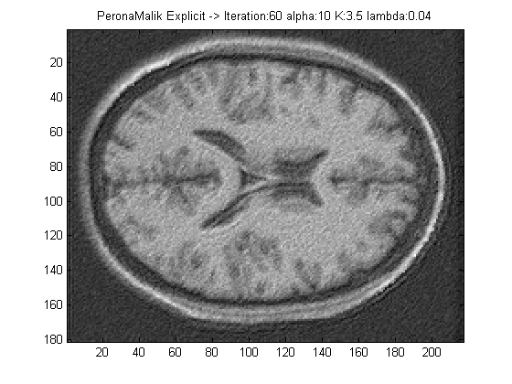
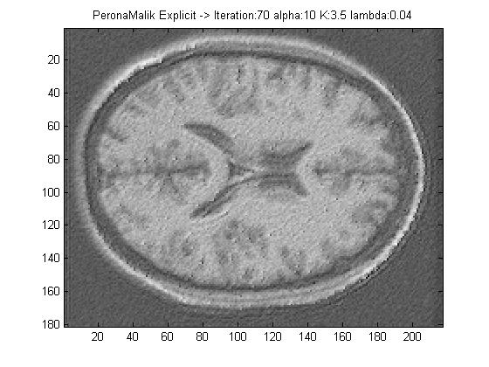 | 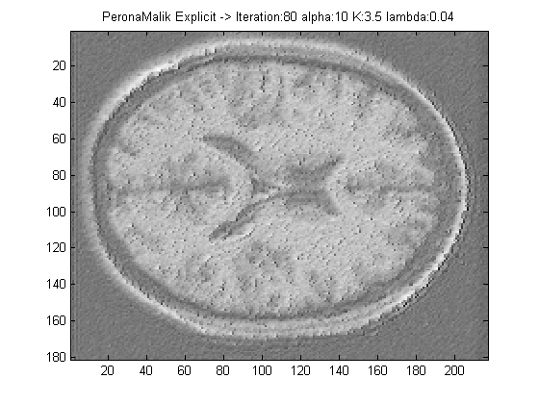
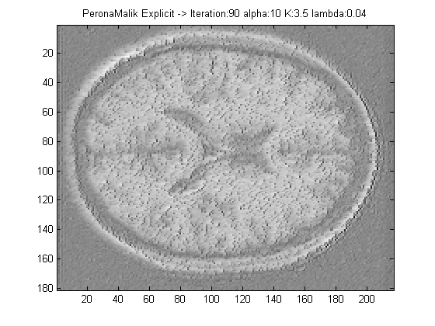 | 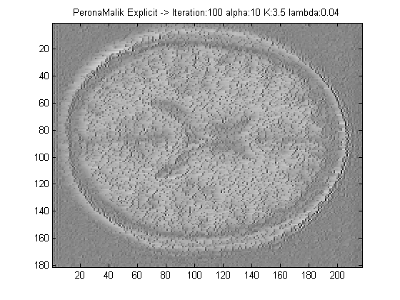
3 Perona Malik Diffusion Process (Implicit Form)
Below are the images for different timestamps at every 10th iteration.
For λ=0.25

