Ekrem Kocaguneli
CS-778
HW#2
Question 1: I used the inflation force that was given in the framework for the homework. The values that I have used are given below
a = 0.02;
b = 0.005;
dt = 0.2;
gamma = 1.0/dt;
exponent = 1000;
offset = 0.01;
K = 0.015;
With the above parameters, the segmentation I achieved is given below:
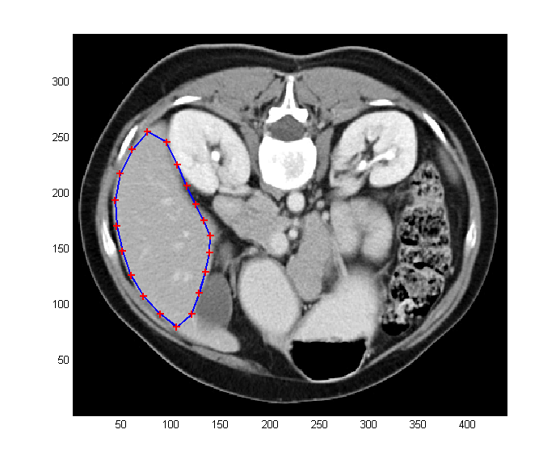

Question 2: For this part, I have incorporated a subdivision scheme, which places midpoints 3 times during the execution of the curve evolution. The midpoint scheme I used is given with the code. The values I used here are the same as those given in the first question. The final figure that I came up with is:
