Ekrem Kocaguneli
CS778
Report for HW # 3

Question 1:
The centroids of the images are:
CI1 = (160.98, 141.58)
CI2 = (171.75, 161.69)

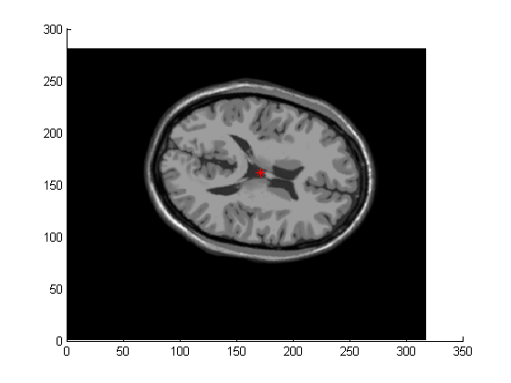
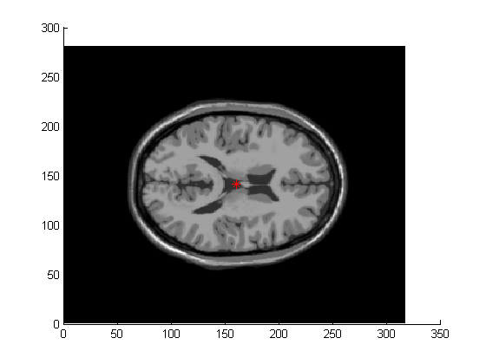
The centroids marked on the images with red stars:

The translation (T) used between I1 and I2 is: T(x) = x + t
To calculate t, I used: t =C I1 – CI2 = (-10.77, -20.11).

Question 2:
The covariance matrices are:
Cov1 =
69,713 | -10,891
-10,891 | 91,438

Cov2=
61,405 | -7,243.3
-7,243.3 | 81,192

Question 3:
Eigenvalue decomposition of the covariance matrices are given by:

[mySigma1 myD1] = eig(cov1); % mySigma's are orthogonal rotation matrices
[mySigma2 myD2] = eig(cov2); % D's are eigenvalues

The related matrix values are as follows:

mySigma1
-0.9236 | -0.3833
-0.3833 | 0.9236
myD1
65,193 | 0
0 | 95,957

mySigma2
-0.9505 | -0.3108
-0.3108 | 0.9505
myD2
59,037 | 0
0 | 83,560

D, which is acos(R) is:

0.0774 | 1.6482
1.4934 | 0.0774

Estimated angle between 2 images is: 0.0774π = 13.93º degrees.

Question 4:
When the image is transformed by imtransform function of matlab, the resulting difference between p3 and p1 (abs(p3-p1)) is given below:

