STAT 745 – HW19 REPORT
EKREM KOCAGUNELI
- Below is the graph for least square boosting applied to generated data for M = 500.

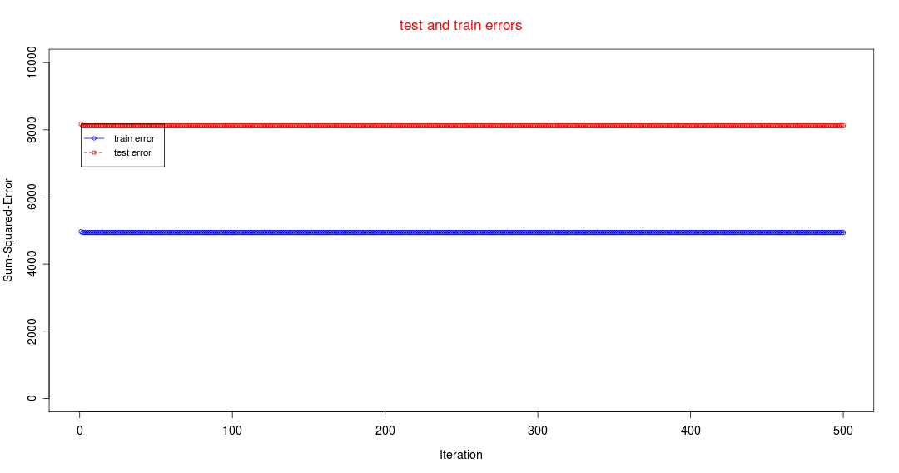
As can be seen from above, there is a very slight movement at iteration 1 or 2, and the tree rarely improves itself throughout 500 iterations of boosting. That is due to the fact that our learning rate implicitly is set to 1 and this almost stabilizes the weights after a couple of iterations, hence we see a solid line. Also note that the blue line for training error is less than the red line which is for testing error, and that is in accordance with our expectations.

- Below are different plots for different learning rates.

Rate=0.05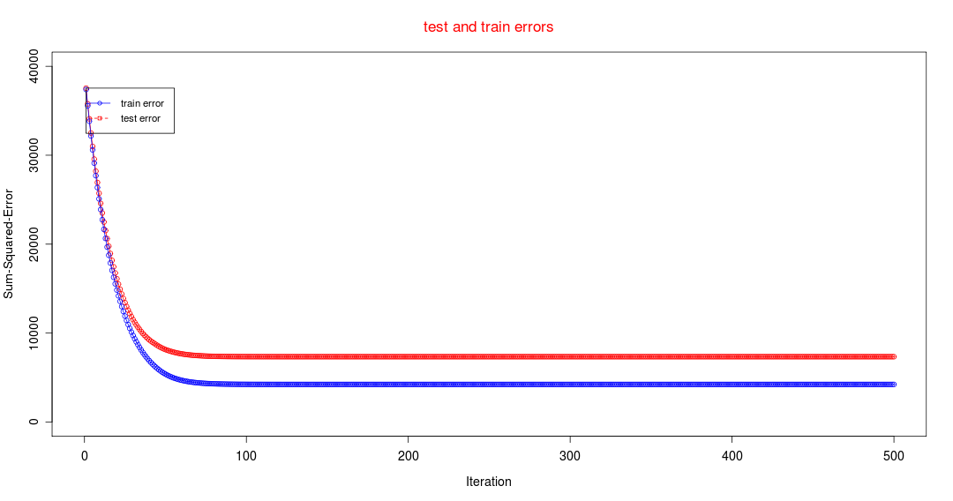
Rate=0.1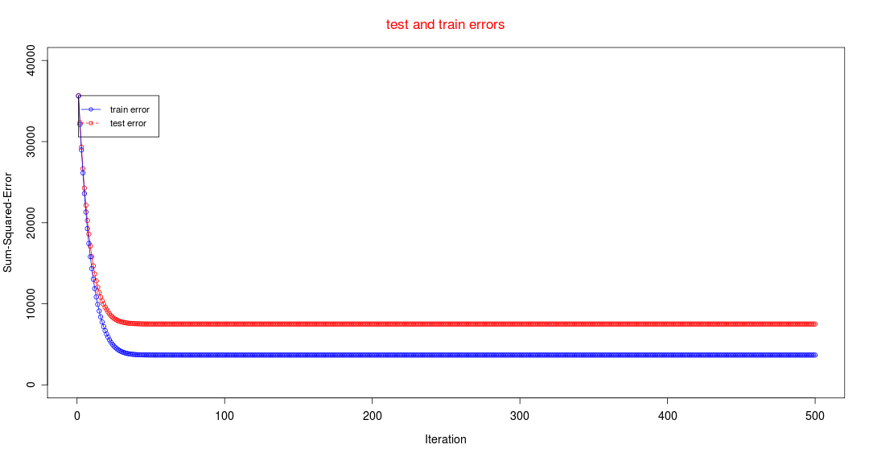
Rate=0.5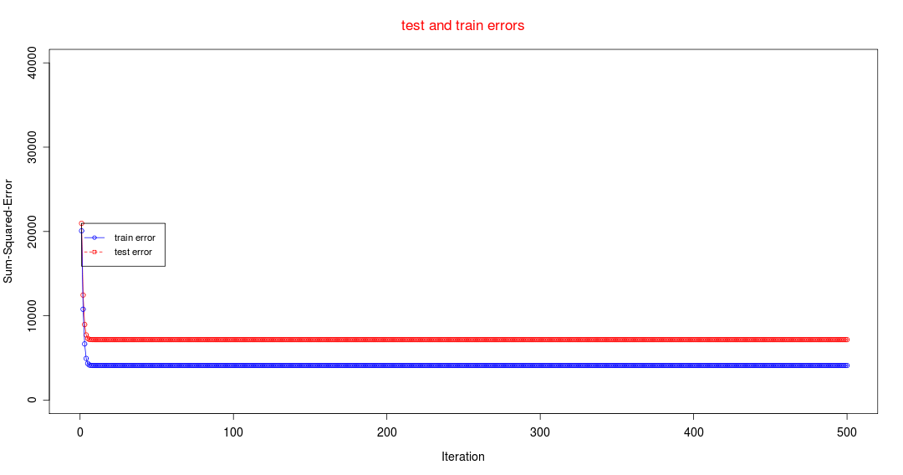
Rate=0.75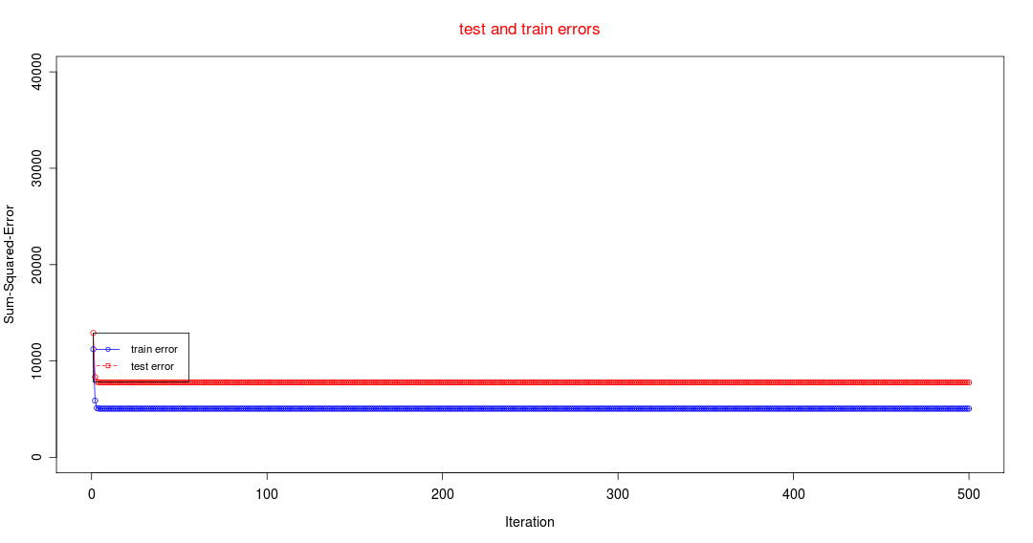

There are two things that we need to explain depending on the above plots: Learning rate and iteration number. As we increase the learning rate, the weights in boosting become more effective. Therefore, within less number of iterations, the learning is achieved and the error rate is virtually stabilized. However, as the learning rate becomes less (as in the case of 0.05) the effect of weights on the boosting become less effective and the learning takes more iterations. So there is a relation between the learning rate and M, which is that it takes less iterations for the algorithm to learn when the learning rate is higher. Also note that in every case, the train error is less than the test error, which is in accordance with the expected. One thing to notice is that the test error does not start to increase after a certain point, which is due to the fact that train and test data are generated by the exact same function.

Among the values that we have tried, the fastest learning was performed using the learning rate of 0.75 and there does not seem to be too much difference in the error rates after stabilization. Therefore, I would say that the higher learning rates are better in that scenario. However, if the data was more difficult and every instance was very different from one another, then I would vote for smaller learning rate (because the data would be more complicated that our generated data) to reduce the impact of every instance and would run the boosting for more iterations.

