Syllabus cs791X : Advanced Data Mining

Syllabus
- Course name: cs791x Advanced Data Mining for Business Intelligence
- Effective data of syllabus: Aug 24, 2011
- Site: LCSEE, WVU
- Course number: ??
- Course format: 3 credit hours 2.5 hr lectures, 1hr lab
- Assessment by project + homeworks + presentations
- Textbooks (both are essential)
ANSI Common LISP : Paul Graham
Data Mining, 2nd edition, Witten & Frank
- Schedule : Tuesday/Thursday 3:30-4:45
- Lab: Thursday 5:6pm
- Instructor name: Tim Menzies Ph.D. ESB 841a, tim@menzies.us. Note: use the above email for private messages. For most of the class traffic, use the class discussion list (http://groups.google.com/group/csx73) and its email csx73@googlegroups.com.
- Consultation times : Tuesday/Thursday 1:00 to 2:00pm, 841a or by appointment

Objectives
Upon successful completion of this course, students should:
- Understand the complexities of applying data mining in a business context
- Understand how to build new data miners (CS.c).
- Understand how to implement data mining tools for the “Zimmermann9” (a spectrum of business intelligence tools- shown below).
- Have knowledge of principles required for the design, implementation and analysis of complex data mining experiments (CS.e).
- Be familiar with advanced concepts of data mining (CS.g.k)
- Be able to communicate ideas effectively: in writing (CS.g.g1)
- Be able to communicate ideas effectively: verbally (CS.g.g2)
- Be able to work and learn effectively as members of a team (CS.g.g3)

Links
- http://www.arc.wvu.edu/courses/ : WVU course pages
- http://www.arc.wvu.edu/examschedule_fall.html : exam schedule page
- The Zimmermann9,: http://tinyurl.com/zimm9, summarized in the following table
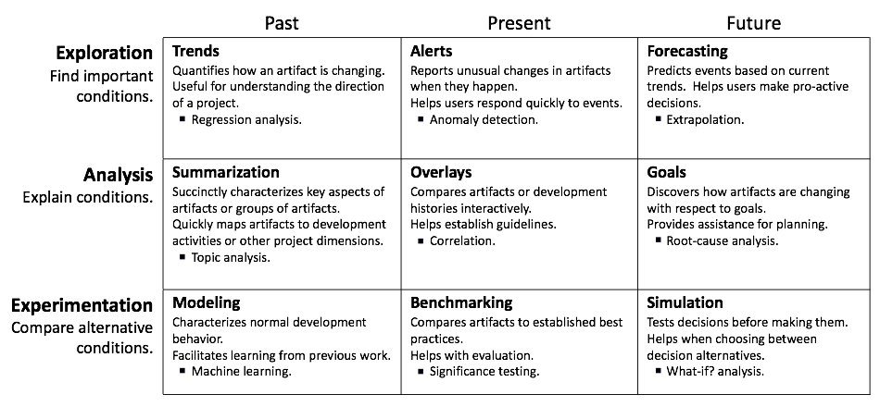

Expected Workload
You MUST be prepared to dedicate AT LEAST 5-8 working hours a week to this class (excluding the time spent in the classroom). A minimal prerequisite for the successful completion is good understanding of programming concepts. You will be given class accounts on CS Department machines and all assignments will have to be submitted and run there. Please note that a Linux server can be accessed from any PC using a secure connection service, such as SSH (explanation to be provided in class).

Assessment
Home works and coding will all be based on coding in a high-level scripting language
24% for 3 weekly home works due weeks 2,4,6 (4 marks each)
20% coding project1 (due week 10)
30% coding project2 (due end of term)
16% final presentation (students graded on the professionalism of their presentation)
10% final report, due 1 week after verbal presentation.

Students can apply, or be ordered by the lecturer, to opt out of the projects. If so, they will write 2*2000 essays for project1 or 3 * 2000 word essays for project2 They will also loose 7.5 marks from their end-of-year grade.

For special consideration on the above, either:
- See me at start of semester advising planned absences or
- For particular absences, provide a medical certificate indicating that the student was unable to work on their studies for a relevant period (that note must NOT name the illness, but should list its duration)

Final Grades
A = 90—100, B = 80...89, C = 70 .. 79, D = 60 .. 69, F = otherwise

Attendance policy
Students are expected to attend most lectures. After 3 noted absences, students will lose 2 points per absence. After 3 noted late arrivals, students will lose one point per late arrival. If you have another commitment that requires you to be consistently late, you should drop the class.

Social Justice Statement
West Virginia University is committed to social justice. I concur with that commitment and expect to foster a nurturing learning environment based upon open communication, mutual respect, and non-discrimination. Our University does not discriminate on the basis of race, sex, age, disability, veteran status, religion, sexual orientation, color or national origin. Any suggestions as to how to further such a positive and open environment in this class will be appreciated and given serious consideration.
If you are a person with a disability and anticipate needing any type of accommodation in order to participate in this class, please advise me and make appropriate arrangements with Disability Services (304) 293-6700 (ph) (304) 293-3861 (fax) access2@mail.wvu.edu

Statement of Academic Integrity
The integrity of the classes offered by any academic institution solidifies the foundation of its mission and cannot be sacrificed to expediency, ignorance, or blatant fraud. Therefore, I will enforce rigorous standards of academic integrity in all aspects and assignments of this course.
For the detailed policy of West Virginia University regarding the definitions of acts considered to fall under academic dishonesty and possible ensuing sanctions, please see the Student Conduct Code at http://grad.wvu.edu/academics/policies_and_guidelines. Should you have any questions about possibly improper research citations or references, or any other activity that may be interpreted as an attempt at academic dishonesty, please see me before the assignment is due to discuss the matter

